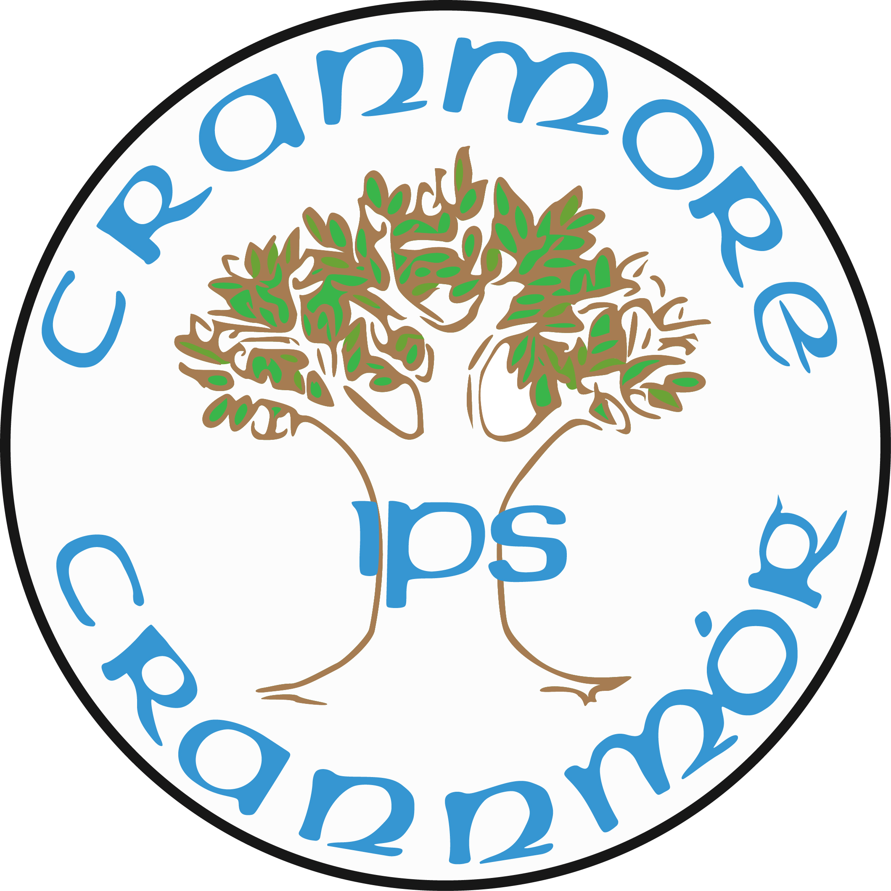

Information for Candidates and guidance notes

Inclusive Hearts, Ambitious Minds
Cranmore Integrated Primary and Nursery School
47 Finaghy Road North, Belfast BT10 0JB
Phone 028 90 664410
Web www.cranmoreips.co.uk
Cranmore Integrated Primary and Nursery School

Contents
History of Integrated Education 1
School Information 2
Recruitment Information 5
Completing your Application Form 7
Completeing your Equal Opportunities Monitoring Form 9
Returning your Application Form 10
The Selection Process 11

History of Integrated Education
Integrated Education in Northern Ireland is a grassroots, community led response to an education system that largely separates children according to their religious and cultural affiliation or background.
Since its foundation in 1921, Northern Ireland’s education system has largely consisted of state controlled schools (mainly attended by protestant pupils) and catholic maintained schools (almost exclusively attended by catholic pupils).
The first attempt to break the established mould of education was the formation of the campaigning group All Children Together, established by parents whose vision was one whereby existing schools could transform to Integrated status.
When no existing schools succeeded in transforming this led directly to the establishment of Lagan College, the first planned Integrated school in Northern Ireland, in 1981.
The Northern Ireland Council for Integrated Education (NICIE) was formed in 1987 as a coordinating body to give advice and guidance to schools and parent groups.
The 1989 education reform order gave the Department of Education statutory responsibility to encourage and facilitate Integrated schooling. Whilst immediate recurrent funding could be given to new schools who met stringent enrolment and growth criteria, there was no provision for capital funding until the schools had demonstrated their viability over time.
There was little support from statutory agencies and at times open hostility to growing integrated provision, even though there was a mechanism enshrined in legislation to permit existing schools to transform to become an integrated school . This resulted in many groups of parents across Northern Ireland organising to guage interest and plan for the opening of grant maintained integrated schools. In 1993 such a group of parents brought about the establishment of Cranmore bringing the number of integrated schools to 19.
In 2014, a High Court judge ruled that the Department of Education needed to be ‘alive to its statutory duty to encourage and facilitate the development of integrated education at a strategic level. Justice Tracey also clarified that the term ‘integrated education’ cannot apply to a school with just mixed enrolments rather to formally constituted schools where integration includes staffing and governance.
In 2022 The Integrated Education Act (Northern Ireland) was passed into law. The Act has defined Integrated Education as the education together of those:
(a) those of different cultures and religious beliefs and of none, including reasonable numbers of both Protestant and Roman Catholic children or young persons;
(b) those who are experiencing socio-economic deprivation and those who are not; and
(c) those of different abilities.
The Act also includes the provision for the Department to bring forward a strategy which reflects the new statutory duty which is not only about encouraging and facilitating but more importantly about supporting integrated education.
School Information

School History
On learning that the local integrated school had to move out of the immediate area early in 1993, some parents already having children at the school decided that the difficulties of transporting children across the city would be too much. Joined by other interested people they set about establishing a new school to serve the Lisburn Road corridor. It was envisaged that the school would also draw pupils from the west of the city. With the help of the Northern Ireland Council for Integrated Education the daunting task of establishing a Grant Maintained Integrated School got under way. Many public meetings with interested parents, meetings to discuss funding and find suitable premises, meetings to appoint staff and a thousand other related tasks took place.
Since then, the school has not looked back. Building work began on the Musgrave site in July 2000 and Cranmore moved to its permanent site in September 2001 to cater for 203 pupils in the first phase of building. We are appreciating a very rewarding and stimulating present while looking to and planning for the future. At present we have 210 pupils enrolled in the primary school and a further 26 children attend our pre-school.
The school grounds are tree-lined and private with tarmaced and grassy areas for the children to enjoy. In 2009 we designed and built a play area for outdoor learning. We also have the benefit of an environmental area in which children can plant and grow flowers. Since 2012 we have been awarded the ‘Green Flag’ every two years in recognition of our commitment to a sustainable school environment. Work is currently underway to complete an outdoor classroom area adjacent to our school orchard.

Development of Preschool education
Our Pre-school facility opened in 2003 with the generous support of Mr Kevin Curley, the American Ireland Fund and the Integrated Education Fund. It is an integral part of the primary school and prides itself on the warm and welcoming environment for both children and parents. The inclusive ethos of the Pre-school ensures that all children have opportunities to learn and play together irrespective of social, religious or cultural background.
In 2015-2016 we moved into brand-new purpose-built accommodation which consists of a mud pie kitchen area, playgrounds, large playroom, quiet room, Kitchen area and office/staff room. The Pre-school children also make use of the school grounds and the school hall for indoor play.
From September 2017 our pre-school has been operating as a Nursery Class with the daily session running from 9:00am until 1:00pm. We currently have 26 part time places in the Nursery the majority of which transfer to the main school for Primary 1.

character & Ethos
As an integrated all-ability primary school, we aim to provide a happy, secure environment in which children can learn effectively to realise their full potential as unique individuals. This aim permeates the ethos of the school, the teaching styles and approaches, the pastoral care arrangements and the discipline policy of Cranmore. As children have different abilities, aptitudes and needs, their performances will vary from their peers, but every opportunity will be given for children to experience success. Positive encouragement and praise for all pupils regardless of gender, colour or creed will enable them to develop intellectually, socially, morally and spiritually and become full contributing members of the school community.
The Board of Governors, Principal and teachers are committed to the establishment of a school which will in particular:
- provide an opportunity for children from the two main traditions in Northern Ireland, as well as those from other traditions and cultures to develop a knowledge, understanding, appreciation and respect for their common culture.
- aim to encourage all pupils to explore and value their own particular tradition so as to encourage the education together of children of various beliefs, cultures and traditions.
- promote a happy and caring environment centered on the needs of the child in preparing him or her for a creative and satisfying life in a pluralist society.
- promote and protect the rights of parents to be involved in the decision making and community life of the school while respecting the role of staff as professional teachers.
- have a belief in educating and cherishing all children, Protestants, Catholics, other faiths and none, on a footing of equality.
- have a belief that an integrated school should be Christian rather than secular in character, and have a commitment to integrated education.
- have an emphasis on child-centered education, and the involvement of parents in the life and work of the school.

curriculum & extra curricular activities
Learning and teaching is planned around the requirements and themes as set out in the Northern Ireland Curriculum. Regular assessment and monitoring of pupil work and standards is used to inform teachers about pupil progress and to forward plan the next lessons.

Opportunities to promote the principles of integrated education occur throughout the school day both in a planned and unplanned fashion.

Throughout the year the school offers a wide variety of extra-curricular activities on a Wednesday and Thursday. Pupils are also encouraged to take part in competitions in relation to music, sport and art.

As an inclusive learning environment, the school attracts pupils with diverse abilities including pupils with additional needs.

In 2023 we repurposed our old playgroup mobile classroom as a dedicated Learning Centre/Library. This allowed us to repurpose our old library (within the main school building) as a dedicated Learning Support classroom with a full time Learning Support teacher who plans and delivers intervention for small groups. The Learning Support Teacher works closely with the Principal and the Learning Support Co-ordinator to ensure that pupils are progressing, targets are appropriately identified, and the provision is kept under review.

As a school we fundamentally belief that any support must also include working alongside class teachers and classroom assistants to ensure that there is further support for pupils when they return to the classroom. This will ensure the pupils receive consistency both in support, teaching approaches and learning targets.

Recruitment Information

INTRODUCTION
The purpose of these guidance notes is to assist you in completing your online application form. Before completing your application form, please make sure that you have access to, and have read, the following documentation:
- Candidate Privacy Notice
- Job Description and/or Person Specification
- Terms and Conditions of Appointment
- Application Form
- Equal Opportunities monitoring Questionnaire
- Health Declaration

Eligibility
Please ensure that you are eligible to apply for the post prior to the completion of an application form.
The school website will display both the Job Description and the Person Specification. The Job Description is a written statement of the purpose, scope, duties and responsibilities of the post. The Person Specification sets out the essential and desirable requirements for the post. The Person Specification is divided into the following categories:
• Qualifications/Professional Membership
• Experience • Knowledge
• Skills/Abilities
• Other Requirements
Essential criteria are those necessary for the post to be performed to satisfactory standards. These form the minimum shortlisting criteria. In the event of large numbers of applicants meeting the essential criteria, the selection panel may wish to apply the desirable criteria. You must demonstrate on your application how you meet the criteria. Only those meeting the agreed criteria at shortlisting will be invited to the next stage of the selection process. Where available, please provide specific examples on your application in the criteria boxes provided of how you meet the criteria listed in the Person Specification.

Terms & Conditions of appointment
Teaching positions
Teachers’ (Terms and Conditions of Employment) Regulations (Northern Ireland) 1987 shall apply to teachers employed in grant-aided schools, peripatetic teachers and supply teachers. Further information is available on the DE website.
Support Staff positions (Non-Teaching in schools)
You will be provided with a link to the summary of terms and conditions of the position to which you are making an application.

Completing your Application Form

candidate privacy notice
Prior to completion of your application form you must read the Candidate Privacy Notice.

completing your application form
It will help candidates for this post - and the panel of governors responsible for making the appointment - if those who make applications:
- refer to the person specification prior to the completion of your application form as there may be difference in the criteria for posts with the same title
- applications are to be made by means of the official application form : letters of application, statements of a curriculum vitae, testimonials or extracts from ETI reports will not be accepted
- the application form must be completed in full and according to the instructions provided, duly signed and dated and arrive at the school prior to the closing date and time
- applications which arrive after this closing date will not be considered
- complete all the sections of the form with factual information. Do not use acronyms or complex technical detail. Make clear your personal involvement in any experience that you are writing about.
- hand-written applications must be in writing that is legible and uses black ink. Alternatively, you may download and complete your application electronically
- applications may be word-processed, but the space provided for responses may not be extended. If you are downloading an application form please ensure that the format is unchanged and that it is emailed in the same format.
- incomplete or altered application forms will bot be considered
- The option to return your form in a hard copy is always available
- any candidate experiencing difficulties completing the application form due to a disability or who have any queries regrading the recruitment process should contact the school for advice
- provide all the evidence that they believe demonstrates that they meet the various criteria set out in the personnel specification and referred to in the form
- sign and date the form
- complete, sign and return the EOP Questionnaire and Health Declaration Form in an envelope marked

Employment Rights
All applicants must ensure that they are free to remain in and take up employment in the United Kingdon. Successful candidates will be required to provide supporting documentation. Details of acceptable documentation is available at www.gov.uk/government/publication/right-to-work-checklist

References
Please provide the details of 2 referees who may be contacted if you are recommended for appointment.
You must provide the details of a least one referee who has the ability to comment on your suitability to work with children in an education setting and your professional ability from your previous or current employer.
Prior ro submitting your application you must have the consent from your referees to provide their details. You must advise your referees of our contact details in the event that a referee wishes to contact us concerning their own personal data.
Please do not submit references with your application form.

Safeguarding & Child Protection
Posts involving work in educational establishments are subject to the provisions of the Safeguarding Vulnerable Groups (NI) Order 2007.
The successful candidate will be required to complete an Access NI disclosure certificate application prior to appointment.
DATA PROTECTION & GDPR
The information on your application form is required for the purpose of processing your application. It is essential that the details you provide on the application form are correct. The data provided will be processed in compliance with the Data Protection Act 1998 (as amended) and the General Data Protection regulation (GDPR).
The Candidate Privacy Notice provided as part of the application pack provides full details on the use of your personal data and the protections and rights available to you in relation to processing sharing and disposal.

Completing your Equal Opportunities Monitoring Form

Equal Opportunities
Cranmore Integrated Primary and Nursery School is an Equal Opportunities Employer and welcomes applicants from people with disabilities.
In accordance with the Disability Discrimination Act, a person is disabled if they have, or have had ‘a physical or mental impairment which has, or has had a substantial and long-term adverse effect on their ability to carry out normal day to day activities.’
Please provide information which is relevant regarding specific requirements that you may have indicated on the Equal Opportunities Monitoring Questionnaire
Cranmore Integrated Primary and Nursery School is an Equal Opportunities Employer and welcomes applicants from people from all religious and or community backgrounds.
Cranmore Integrated Primary and Nursery School was established under Articles of Association on 24 February 1993.
In the Articles of Association provision is made to ensure: ‘that at least 40% of the staff are of the Catholic tradition and at least 40% of the Protestant tradition’
As a grant maintained integrated school we endeavour to ensure that a community balance is reflected among our staff and pupils and also the governing body.
The Integrated Education Act (Northern Ireland 2022) places legal duties on the Department of Education to monitor and report on the implementation of the Act.
To comply with the Fair Employment & Treatment (NI) Order 1998 you must complete the questions in relation to perceived community background. This allows us to monitor and report on the representation of the school workforce and also helps us to maintain our community balance of 40:40:20 as set out for all Integrated Schools.
Please not the Equal Opportunities Monitoring Questionnaire is not presented to the selection panel.

Returning Your Application Form
Completed Application forms including the Health declaration and Equal Opportunities Form must be returned before the specified closing time and date by on of the following methods:
- Hand delivered to the School Office
- Email to info@cranmore.belfast.ni.sch.uk.
- Post – 47 Finaghy Road North, Belfast BT10 0JB.

The Selection Process

Shortlisting
Please demonstrate clearly how you meet the essential criteria and provide any relevant information on how you mee the desirable criteria. It is also important to consider that, where there is a minimum requirement, this criterion may be enhanced.
It should be noted that shortlisting will be based solely upon information provided on your application form. Members of the shortlisting panel are not permitted to take into consideration information known to them personally about your application or to make any assumptions about the information which you have provided.

interview
Those short-listed for interview may be invited to visit the school beforehand and given an opportunity to meet the principal. If these arrangements apply to the post you will be contacted by ths School Office. Being able to visit the school has no bearing at all on your application.

Full details of what the interview stage involves will be given to all those short-listed well in advance of the date set aside for it and the panel of governors responsible for making the appointment reserves the right to go to a second round of interviews, if necessary.

If you are unable to attend the interview at the date and time specified, or wish to withdraw from the selection process, it is essential that you contact the school at the earliest opportunity. A request for an alternative interview date will only be considered in exceptional circumstances and will be at the absolute discretion of the selection panel.

No payment will be made for travelling or removal expenses incurred by candidates

Successful candidates
If the post is offered to one of those short-listed and he or she accepts, the panel of governors will confirm the appointment only after all the conditions on which it is offered have been fully met.

This includes:
- Satisfactory Enhanced Disclosure Certificate
- Receipt of original Birth Certificate
- Receipt of original documentary evidence of qualifications which formed shortlisting criteria.
- Receipt of 2 satisfactory references

A letter of appointment will be issued and should be signed and returned as an indication of your desire to take up the post.

The school may, at its discretion, require a candidate to attend a medical examination.

