Cranmore Integrated Primary

and Nursery School



Inclusive Hearts, Ambitious Minds

Policy for

Addressing Bullying in Schools

School Vision
To nurture confident, compassionate learners in an inclusive environment, empowering every child to thrive and contribute to a brighter future.

Mission Statement
At Cranmore IPS, we are committed to building a welcoming community and secure learning environment rooted in trust, respect, and teamwork. We celebrate diversity, nurture self-worth, and deliver a progressive curriculum that challenges and supports all learners. Together, we inspire young minds and foster a lifelong love of learning, equipping every child for success in an ever-changing world.

School Ethos
In line with the vision and aims of our school, at Cranmore Integrated Primary and Nursery School, we believe all forms of bullying behaviour are unacceptable. We believe that all pupils have the right to learn and staff have the right to work in a safe and supported environment. As an integrated school we are committed to a society where children and young people can live free and safe from bullying and where diversity is celebrated. We are committed to a preventative, responsive and restorative anti-bullying ethos across the whole school where everyone in our school community has a role to play in taking a stand against bullying and creating a safe and welcoming environment for all. We are committed to a preventative, responsive and restorative anti-bullying ethos across the whole school.

Context
This policy is informed and guided by current legislation and DE Guidance listed below:
The Legislative Context:
- Health and Safety at Work NI Order 1978
- The Children (Northern Ireland) Order 1995
- The Human Rights Act 1998
- The Education (Northern Ireland) Order 1998 Article 3 – see DE 1998/25
- WELFARE AND PROTECTION OF PUPILS EDUCATION AND LIBRARIES (NORTHERN IRELAND) ORDER 2003
- THE EDUCATION (2006 ORDER) (COMMENCEMENT NO.2) ORDER (NORTHERN IRELAND) 2007
- The Education (School Development Plans) Regulations (Northern Ireland) 2010
- Addressing Bullying in Schools Act (Northern Ireland) 2016

DE Guidance:
- Pastoral Care in Schools: PROMOTING POSITIVE BEHAVIOUR DE, 2001
- Safeguarding and Child Protection in Schools. A Guide for Schools DE 2017 – to be read in conjunction with the following Co-operating to Safeguard Children and Young People in Northern Ireland, Dept. of Health, Social Services and Public Safety 2016 Safeguarding Board for Northern Ireland’s (SBNI) Policies and Procedures 2017
- Addressing Bullying in Schools Act (Northern Ireland) 2016 Statutory Guidance for Schools and Boards of Governors 2019

The International Context:
- United Nations Convention on the Rights of the Child (UNCRC)
The key points to note are:
- The Addressing Bullying in Schools Act (Northern Ireland) 2016:
  - Provides a legal definition of bullying.
  - Places a duty on the Board of Governors to put in place measures to prevent bullying behaviour, in consultation with pupils and parents.
  - Requires schools to record all incidents of bullying behaviour and alleged bullying incidents.
  - Sets out under which circumstances this policy should be applied, namely:
    - In school, during the school day
    - While travelling to and from school
    - When under control of school staff, but away from school (eg. school trip)
    - When receiving education organised by school but happening elsewhere (eg. in another school or at an event where they are representing the school)
  - Requires that the policy be updated at least every four years.

- The Education and Libraries Order (NI) 2003, requires the Board of Governors to:
  - ‘Safeguard and promote the welfare of registered pupils’ (A.17)

- The United Nations Convention on the Rights of the Child (UNCRC) sets out every child’s right to:
  - Be protected from all forms of physical or mental violence, injury or abuse, maltreatment or exploitation. (A.19)
  - Be protected from discrimination. (A.2)
  - Express their views, in a supported and accessible way, on issues that affect them, and to have their opinions taken seriously. (A.12)
  - Education. (A.28)
This Policy should be read in conjunction with the wider pastoral care and safeguarding policies including:
- Positive Behaviour Policy
- Well-Being Policy
- Integration Policy
- Pastoral Care Policy
- Safeguarding and Child Protection Policy
- Special Educational Needs Policy
- Health and Safety Policy
- Relationships and Sexuality Education
- E-Safety Policy & Acceptable Use of Internet Policy
- Educational Visits
- Staff Code of Conduct

Consultation and Participation
This policy has been developed in consultation with students, parents/carers and staff, in compliance with the Addressing Bullying in Schools Act (NI) 2016. Consultation involved the following:
Pupils
Discussions with the Pupil Council
Share with pupils in assembly.
Class based activities on anti-bullying work.
Pupil questionnaires for KS2

Parents
Shared with parents via Seesaw
Parent Questionnaires
Shared with BOG and parent representatives in draft form.
Information Leaflet shared annually with parents.

Staff
Consultation with all staff during INSET sessions.
Members of the SLT and Safeguarding Team involved in updating the policy for anti-bullying
Staff review of the policy before ratification by the Board of Governors

What is Bullying Type Behaviour?
Definition of “bullying”:
1.(1) In this Act “bullying” includes (but is not limited to) the repeated use of:
(a) any verbal, written or electronic communication;
(b) any other act; or
(c) any combination of these, by a pupil or a group of pupils against another pupil or group of pupils, with the intention of causing physical or emotional harm to that pupil or group of pupils.

(2) For the purposes of subsection (1), “act” includes omission.
(The Addressing Bullying in Schools Act (Northern Ireland) 2016)

Bullying is therefore a deliberate act, which is usually but not always repeated, carried out against a pupil or group of pupils by another individual or group with the intention of causing upset or harm.
One-off Incidents
When assessing a one-off incident, to make a decision on whether to classify it as bullying type behaviour, the school shall consider the following criteria:
- severity and significance of the incident
- evidence of pre-meditation
- impact of the incident on individuals (physical/emotional)
- impact of the incidents on wider school community
- previous relationships between those involved
- any previous incidents involving the individuals
Any incidents which are not considered bullying type behaviour will be addressed under the Positive Behaviour Policy.
Language
Bullying is an emotive issue, therefore it is essential that we ensure we use supportive, understanding language when discussion these matters. For that reason we will not refer to a child as ‘a bully’, nor will we refer to a child as ‘a victim’. Instead, we will refer to the child by describing the situation surrounding that child:
- A child displaying bullying type behaviours
- A child experiencing bullying type behaviours
We encourage all members of the school community to use this language when discussing bullying type incidents.

Socially Unacceptable Behaviour
The following unacceptable behaviours, when repeated, targeted and intentionally hurtful, may be considered a bullying type behaviour:

Verbal or written acts
- saying mean and hurtful things to, or about, others
- making fun of others
- calling another pupil mean and hurtful names
- telling lies or spread false rumours about others
- try to make other pupils dislike another pupil/s

Physical acts
- Hitting
- kicking
- pushing
- shoving
- material harm, such as taking/stealing money or possessions or causing damage to possessions
Omission (Exclusion)
- Leaving someone out of a game
- Refusing to include someone in group work
Electronic Acts
- Using online platforms or other electronic communication to carry out many of the written acts noted above
- Impersonating someone online to cause hurt
- Sharing images (eg. photographs or videos) online to embarrass someone
(This list is not an exhaustive list and there are other behaviours which may be considered socially unacceptable/ bullying type behaviour).

In determining ‘harm’ we define:
- Emotional or psychological harm as intentionally causing distress or anxiety by scaring, humiliating, or affecting adversely a pupil’s self-esteem.
- Physical harm as intentionally hurting a pupil by causing injuries such as bruises, broken bones, burns or cuts.
(Guidance from DE).
Criteria for assessing allegations of bullying type behaviour are outlined below:
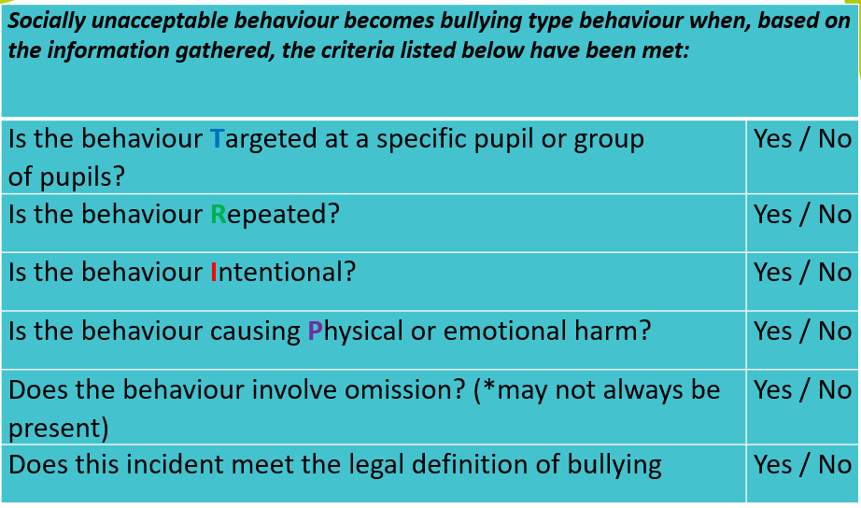
DISCRETION:
The 2016 Act requires schools to consider the following when assessing whether an incident/s meet the legal definition of bullying type behaviour:
- pupil/s capacity to regulate and understand the impact of their behaviour.
- developmental age
- Additional needs, SEN, behaviours displayed (diagnosed or undiagnosed e.g. SBEW, ASD, FASD, MLD etc.)
- Individual challenges e.g family circumstances, trauma etc
- Levels of resilience.
All behaviour is communication to be addressed through a child/young person lens, for both those displaying and experiencing socially unacceptable/bullying type behaviour, no label or blame will be put on any individual. We will address all incidents in a relational, solution focused manner aligned to Safeguarding and SEND.
Methods & Motivations of Bullying Type Behaviour
Individuals who display bullying type behaviour may have various methods and motives. Some examples are, but are not limited to:
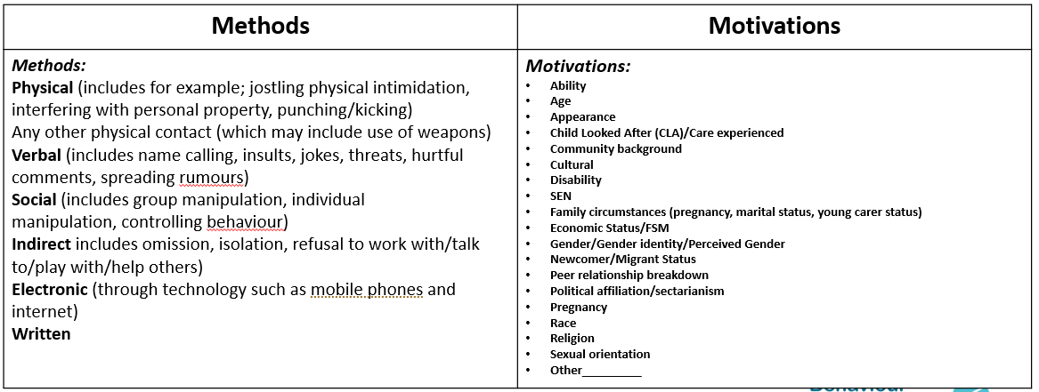
Preventative Measures
Legislation reinforces the importance of preventative measures. In Cranmore we aim to create and maintain a safe learning environment. We will put measures in place to prevent, address and support bullying type behaviour within our school and wider community. There follows some of the key actions that will be taken forward, to create a safe, relational, nurturing learning environment.
In School
- Raising awareness and understanding of the positive behaviour expectations, as set out in the Promoting Positive Behaviour Policy
- Promotion of anti-bullying messages through the curriculum eg. inclusion of age-appropriate material specific to individual subject areas related to bullying, positive behaviour and inclusion
- Addressing issues such as the various forms of bullying, including the how and why it can happen, through PDMU (eg. sectarian, racist, homophobic, transphobic, disablist, etc.)
- Involvement in meaningful and supportive shared education projects, supporting pupils to explore, understand and respond to difference and diversity.
- Through the preventative curriculum actively promote positive emotional health and wellbeing (eg. Take 5)
- Participation in the NIABF annual Anti-Bullying Week activities
- Engagement in key national and regional campaigns, eg Safer Internet Day, Children’s Mental Health Week etc.
- Development of peer-led systems (eg. Pupil Council and House Captains) to support the delivery and promotion of key anti-bullying messaging within the school
- Development of effective strategies for playground management, eg. Appropriate adult supervision, P7 lunch time monitors
- Focused assemblies to raise awareness and promote understanding of key issues related to bullying.
- Development of effective strategies for the management of unstructured times (appropriate supervision and play activities)
- After School activities aimed at supporting the development of effective peer support relationships and networks.
- Circle Time
- PDMU lessons
- PATHS lessons
- Citizenship workshops
- Whole school Assemblies
- Anti-Bullying Week Workshops
- Buddy system for all new pupils
- Safer internet day and E-Safety education.
- NSPCC workshops.
- School counselling service
- Behaviour Logs
- Pupil Council
- House Captains and House Points System
- Weekly Wizz Kid

On the Journey To and From School
- Development of a culture where pupils take pride in their school and are viewed as ambassadors for Cranmore within the community. This includes regular reminders of the positive behaviour expectations of pupils whilst travelling to and from school.
- Measures to empower pupils to challenge inappropriate and unacceptable behaviour of their peers during the journey to and from school through morning bus monitors and afternoon adult bus supervisors.
- Regular engagement with transport providers – (Translink and Best Buses) to ensure effective communication and the early identification of any concerns.
- Promotion of key anti-bullying messages and awareness of behaviour expectations of pupils amongst the local community including information on how to raise any concerns with the school.
- Appropriate deployment of staff to support the transition from school day to journey home through gate duty and bus supervision.
Through Electronic Communications
- Address key themes of online behaviour and risk through PDMU and UICT including understanding how to respond to harm and the consequences of inappropriate use.
- Participation in Anti-Bullying Week activities.
- Engagement with key statutory and voluntary sector agencies (eg. C2k, PSNI, Public Health Agency, Safeguarding Board for NI e-Safety Forum) to support the promotion of key messages.
- Participation in annual Safer Internet Day and promotion of key messages throughout the year.
- Acceptable Use of the Internet Policy including Filtering and Blocking Policy, Mobile Phone Policy.
Given the nature of technology, as constantly changing and developing, school will monitor policy and message and make changes when necessary.

Responsibilities
Everyone in the school community, including pupils, their parents/carers and the staff of the school are expected to respect the rights of others to be safe.
Everyone has the responsibility to work together to ensure the following rights are met for everyone:
  - foster positive self-esteem
  - behave towards others in a mutually respectful way
  - model high standards of personal pro-social behaviour
  - be alert to signs of distress* and other possible indications of bullying type behaviour
  - inform the school of any concerns relating to bullying type behaviour
  - refrain from becoming involved in any kind of bullying type behaviour, even at the risk of incurring temporary unpopularity.
  - refrain from retaliating to any form of bullying type behaviour
  - intervene to support any person who is being bullied, unless it is unsafe to do so.
  - report any concerns or instances of bullying type behaviour witnessed or suspected, to a member of staff.
  - emphasise the importance of seeking help from a trusted adult about bullying type behaviour when it happens or is observed
  - explain the implications of allowing the bullying type behaviour to continue unchecked, for themselves and/or others.
  - listen sensitively to anyone who has experienced bullying type behaviour, take what is said seriously, and provide reassurance that appropriate action will be taken
  - know how to seek support – internal and external
  - resolve difficulties in restorative ways to prevent recurring bullying type behaviour and meet the needs of all parties.

How to Report Cases of Alleged Bullying Type Behaviour.

Any pupil can raise a concern about bullying type behaviour whether they are the person experiencing the behaviour, if they have witnessed it or if a friend has told them about it. It is All staff will reinforce the importance of ‘getting help’ if they have a concern rather than ‘telling’.
Pupils can bring concerns to the attention of any member of staff in a variety of ways:
- Telling their teacher or classroom assistant
- Worry boxes in foyer and Resource Area 2 that are checked on a regular basis
- Circle Time
- Confidential letter left on teacher’s desk
- Telling parents to tell the teacher either by letter or by message on Seesaw or through class page on the website.
- Talking to Principal or other member of staff if the pupil feels uncomfortable about approaching their class teacher.

Parents/Carers Reporting a Concern
- In the first instance, all bullying concerns should be reported to the Class Teacher
- Where the parent is not satisfied that appropriate action has been taken to prevent further incidents, or where further incidents have taken place, the concern should be reported to Miss Dobbin, the Vice-Principal.
- Where the parent is not satisfied that appropriate action has been taken by the Vice-Principal to prevent further incidents, or where further incidents have taken place, the concern should be reported to Mr Doherty, Principal.
Where the parent/carer remains unsatisfied that the concern has not been appropriately responded to, the school’s complaints procedure should be followed. This involves making a formal, written complaint, to the Chair of the Board of Governors via the school office.
All reports of bullying concerns received from pupils and/or parents/carers will be responded to in line with this policy and feedback will be made to the person who made the report. However, it must be noted that no information about action taken in relation to a pupil can be disclosed to anyone other than the pupil and his/her parents/carers.
Responding to a Bullying Concern
In Cranmore we believe in the use of a restorative approach to responding to bullying type behaviour. We will adopt interventions like those advised in the Effective Responses to Bullying Behaviour resource. If deemed necessary and appropriate, school staff may implement sanctions for those displaying bullying type behaviour in line with the Promoting Positive Behaviour Policy.
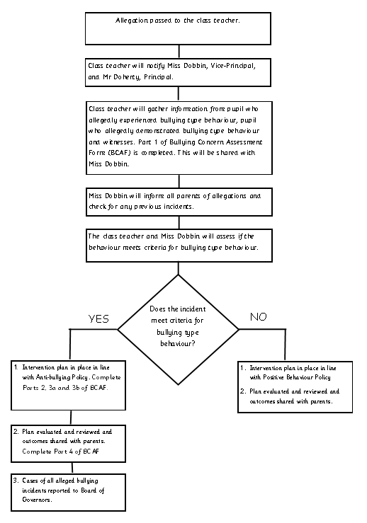
Recording Incidents of Alleged Bullying Type Behaviour
School will centrally record all relevant information related to reports of bullying concerns, including:
- how the bullying behaviour was displayed (the method)
- the motivation for the behaviour
- how each incident was addressed by the school
- the outcome of the interventions employed.

Records will be kept centrally on Private 2, which is part of the C2k system in schools. Access to these records will be restricted and only available to Miss Dobbin and Mr Doherty.
All records will be maintained in line with relevant data protection legislation and guidance and will be disposed of in line with the school’s Retention and Disposal of Documents Policy. Collated information regarding incidents of bullying and alleged bullying behaviour will be used to inform the future development of anti-bullying policy and practice within the school.
Professional Development of Staff
The school recognises the need for appropriate and adequate training for staff, including teaching and non-teaching school staff. The school is committed to:
- ensuring that staff are provided with appropriate opportunities for professional development as part of the school’s ongoing CPD/PRSD provisions.
- noting the impact of the training given on both the policy and its procedures - e.g. any amendments made, inclusions added etc.
- ensuring that opportunities for safeguarding training are afforded to Governors and all staff, teaching, and non-teaching.
- Staff CPD records will be kept and updated regularly.

Monitoring and Review of Policy
It is the responsibility of the Board of Governors, in liaison with the principal, to monitor the effectiveness of the Addressing Bullying Policy. To this end this Anti-Bullying Policy shall be reviewed as required, in consultation with pupils and their parents/carers, at least every four years or when updates are required or suggested by DE Guidance.

To appropriately monitor the effectiveness of the Anti-Bullying Policy, the Board of Governors shall:
- include in the Principal’s Report of each meeting of the Board any alleged incidents of bullying
- identify trends and priorities for action
- assess the effectiveness of strategies aimed at preventing bullying type behaviour
- assess the effectiveness of strategies aimed at responding to bullying type behaviour.

