Cranmore Integrated Primary

and Nursery School

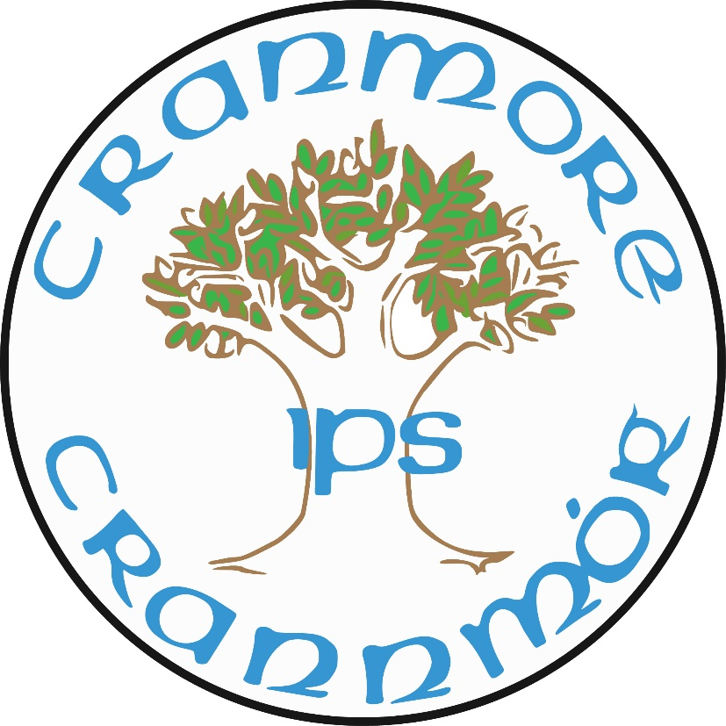

Inclusive Hearts, Ambitious Minds

Policy for RSE

School Vision
To nurture confident, compassionate learners in an inclusive environment, empowering every child to thrive and contribute to a brighter future.

Mission Statement
At Cranmore IPS, we are committed to building a welcoming community and secure learning environment rooted in trust, respect, and teamwork. We celebrate diversity, nurture self-worth, and deliver a progressive curriculum that challenges and supports all learners. Together, we inspire young minds and foster a lifelong love of learning, equipping every child for success in an ever-changing world.

Document Purpose

It is a statutory requirement that all schools in Northern Ireland have a ‘Relationship and Sexuality Education’ RSE Policy.

This policy has been written in line with Department of Education N.I. requirements and through
consultation with parents/carers, staff, and governors and has been ratified by the Board of Governors. It will be updated annually where necessary.

The general aim of education is to contribute towards the development of all aspects of the individual, including the aesthetic, creative, critical, cultural, emotional, intellectual, moral, physical, political, social and spiritual development for personal and family life, for working life, for living in the community and for leisure. Relationships and sexuality Education (RSE) is clearly a part of this general aim. (RSE Guidance for Primary Schools)

Relationships and Sexuality education is an integral part of the Northern Ireland Curriculum in primary schools and must be delivered in a sensitive manner, which is appropriate to the age and undertsanding of pupils and the ethos of the school.

The provision of RSE is an equal opportunities issue. All pupils have a right to an education, which adequately prepares them for adult life, and good RSE plays an integral part. (This policy takes account of the Equality Act NI 2006 and the United Nations Convention on the Rights of the Child).

As a Rights Respecting School it is imperative that the rights of the child are respected and that children within our care are not only given a good quality education but as Article 34 of the UNCRC that all children are protected from sexual abuse and exploitation, through the use of ‘keeping safe’ messages.

The teaching of RSE can have a positive effect on self-esteem. Schools can help to develop their pupils’ self-esteem by creating a climate of trust and acceptance in which each person is valued and respected and encoraged to feel good about themselves. Pupils are encouraged to recognise their individual needs, to respect the needs and wants of others, and to develop the skills and self-esteem to become confident adolescents. RSE in schools can increase infomred choices by providing opportunities for pupils to examine theirown values and beliefs in the light of those held by others. Deeper understanding of the values and beliefs that they can hold can help pupils to clarify why they think and behave as they do, to separate fact from fiction, to recognise prejudice and to respect the views, emotions and feelings of others.

This policy reflects the values and philosophy of Cranmore Integrated Primary School in relation to the teaching and learning in Relationships and Sexuality Education (RSE).

Introduction

Relationships and Sexuality Education (RSE) is:

‘…a lifelong process which encompasses the acquisition of knowledge, understanding
and skill, and the development of attitudes, beliefs and values about personal and social relationships and gender issues.’

Sexuality includes all aspects of the human person that relate to being male or female and is subject to change and development throughout life. Sexuality is an integral part of the human personality and has biological, cultural, psychological, social and spiritual dimensions. It especially concerns affectivity, the capacity to give and receive love; procreation and, in a more general way, the aptitude for forming relationships with others. It is a complex dimension of human life and relationships.

Teaching RSE should provide opportunities which enable pupils to:
- form values and establish behaviour with in a moral, spiritual and social framework;
- examine and explore the various relationships in their personal lives;
- learn how to develop and enjoy personal relationships and friendships which are based on responsibility and mutual respect;
- build the foundations for developing more personal relationships in later life;
- make positive, responsible choices about themselves and others and the way they live their lives.

Aims of the Relationships and Sexuality Policy

RSE aims to:
- Enhance the personal development, self-esteem and well-being of the child;
- Help the child develop healthy and respectful friendships and relationships;
- Examine, explore and value the various relationships within the lives of all children.
- Foster an understanding of, and a healthy attitude to, human sexuality and
relationships in a moral, social and spiritual framework;
- Promote responsible behaviour and the ability to make informed choices about themselves and others;
- Help the child come to value family life;
- Appreciate the responsibilities of parenthood;
- Promote an appreciation of the value of human life and the wonder of birth;
- To develop an understanding of what constitutes sexual abuse/exploitation and where to seek advice if they are worried about any personal matters.
- Help children to keep safe in a digital world
- Promotes a better understanding of diversity and inclusion

Learning Objectives

The RSE curriculum should enable pupils to:
- acquire and develop knowledge and understanding of self;
- develop a positive sense of self-awareness, self-esteem and self worth;
- develop an appreciation of the dignity, uniqueness and well-being of others;
- understand the nature, growth and development of relationships within families, in friendships and in wider contexts;
- develop an awareness of differing family patterns;
- develop strategies to make decisions, solve problems, and implement actions in various personal, social and health contexts;
- become aware of the variety of ways in which individuals grow and change and understand that their developing sexuality is an important aspect of self-identity;
- develop personal skills which will help to establish and sustain healthy personal relationships;
- develop some coping strategies to protect self and others from various forms of abuse;
- acquire and improve skills of communication and social interaction;
- acquire and use an appropriate vocabulary to discuss feelings, sexuality, growth and human development;
- develop a critical understanding of external influences on lifestyles and decision making.

Skills

The RSE curriculum should enable pupils to develop the skills necessary to form and maintain relationships and to make informed choices and decisions regarding health and well-being. Pupils should also be helped to develop skills to critically evaluate the wide range of information, opinions, attitudes and values. They need opportunities to develop:

- practical skills for everyday living; for supporting others; for future parenting;
- communication skills - learning to listen, listening to others’ points of view; putting one’s own view forward clearly and appropriately; giving and receiving feedback; handling and resolving conflict peacefully; being assertive;
- decision-making and problem-solving skills for sensible choices made in the light of relevant information; making moral judgements about what to do in actual situations and putting these judgements into practice; acting responsibly and with initiative as an individual or as a member of a variety of groups;
- inter-personal skills for managing relationships confidently and effectively; for developing as an effective group member or leader.

Relationships and Sexuality Education should be tailored to the age, maturity and understanding of the pupils. The programme therefore aims to present facts in an objective, balanced and sensitive manner, set within a clear framework of values and awareness of the law on sexual behaviour.

Morals & Values

RSE should enable pupils to clarify what they believe and why they believe it and develop a respect for and interest in the beliefs of others. Pupils need opportunities to explore values and attitudes and to consider how they affect them and others.

Children should be taught RSE within a framework which models and encourages the following values:
- a respect for self;
- a respect for others;
- non-exploitation in relationships;
- commitment, trust and bonding within relationships;
- mutuality in relationships;
- honesty with self and others;
- a development of critical self-awareness for themselves and others;
- an exploration of the right, duties and responsibilities involved in relationships
- compassion, forgiveness, mercy and care when people do not conform to their way of life;
- self-discipline

Roles and Responsibilities

- The Board of Governors examines and ratifies the school’s RSE Policy.
- The PDMU co-ordinator on behalf of the Principal and Senior Leadership Team co-ordinates the school’s approach to RSE.
- They consult with the Board of Governors, staff, pupils, parents/carers, and health professionals.
- The staff provide a link and have a complementary role with parents/carers and deliver the school’s RSE programme within the context of the Northern Ireland Curriculum.

School Ethos

As an integrated school we have an ethos which is inclusive of all and which seeks to work co-operatively with parents whilst also delivering the statutory elements of the Northern Ireland Curriculum. All integrated schools have a broadly Christian ethos but we also take note of other faiths and beliefs. Keeping parents informed about the school’s provision is a vital element of RSE. Informal sessions may be arranged so that parents/carers can consider issues such as content or readiness of children for aspects of the RSE programme and/or how sensitive issues will be dealt with.

There is no statutory right for a parent to withdraw a child from classes in RSE. We will consider any parental concerns expressed, attempt to deal with any misunderstandings, identify the specific issues and lessons which are problematic and explain the implications for the pupils in terms of the parts of the statutory programmes of study which will be missed.

The social and emotional effects of exclusion should be considered as well as the likelihood that pupils will discuss the content of the RSE lesson outside the classroom. However, the school will as far as possible try to arrive at a mutually acceptable resolution.

Confidentiality & Safeguarding Issues

Where there is a disclosure of alleged abuse this will be addressed via the Child Protection & Safeguarding procedures.

The classroom is an open environment and confidentiality cannot be maintained. The child’s right to privacy must be respected at all times by staff and other pupils. A key rule to agree in advance of any discussion is that no one will be expected to ask or answer any personal questions. It is equally important that the teacher shared this right and never feels obliged to impart information about their own personal life.

Equal Opportunities and Special Needs

The RSE programme will meet the needs of both genders, it is developmental and appropriate to the age and maturity of the pupils. As maturity is not always determined by chronological age, teachers are sympathetic to the personal and emotional circumstances of each individual pupil. It should meet the needs of gender and be a positive experience for all participants. Boys and girls are encouraged to work with each other and gain an understanding of each other’s perspectives. However, there will be times that teachers or outside professionals will work with single gender groups, eg P7 to explore puberty related physical and emotional changes in both boys and girls. The programme of RSE delivered will be accessible to all pupils regardless of age, ability, culture, disability, sexual orientation, gender or social class.

Use of Visitors & Staff Training

Training needs will be considered and will be accessed using the Education Authority, Public Health Agency and or appropriate health agencies. Where outside agencies are used for training purposes their remit will be clear and will reflect the ethos of the school.

Curriculum Content and Delivery

RSE will be taught across the curriculum, mainly through PDMU but also in the WAU and RE. Although specific topics will be addressed, other areas may arise incidentally and will be treated with sensitivity. Staff will use a variety of teaching strategies and approaches in keeping with the maturity of pupils. This will also include the usage of correct terminology for example in naming parts of the body.

Topics and themes are often repeated at regular intervals. The sequence in which ideas are presented below is not intended to imply a teaching order.

FOUNDATION STAGE AND KEY STAGE 1
Myself

- Myself: how I grow, feed, move and use my senses; caring for myself, for example, hygiene, sleep, exercise.
- Naming parts of the body (basic) - developing an agreed language for our bodies.
- Being myself - I am unique, my self-esteem, self-confidence, independence, respect and caring for myself.
- Similarities and differences between myself and others, for example, uniqueness, fingerprints, gender issues, different rates of growth.
- An introduction to the stages of human development - changes as we grow, for example, baby, child, teenager, adult, mother/father, grandparents.
- Recognising moods, feelings and concerns and developing a language and an
- appropriate manner of expressing them, for example, What do I do if I feel sad or angry?
- Personal likes and dislikes.

My Relationships

- My family, special people in my life - what they do for me and what I do for them.
- Friendships, getting on with each other, for example, communicating, playing together, listening, co-operating and sharing.
- Ageing- how do we know that things are alive, dead, young and old.
- Loss and mourning - death of a person or a pet. (Note: the situations of the pupils should be taken into account prior to introducing this topic.)
- Respect and caring for family members and friends, for example, caring for a new baby.
- Bullies and what to do about them.
- Personal safety - simple skills and practices to maintain personal safety.
- The difference between good and bad touches.
- Realise that adults and older children are not always friends; the potential danger of relationships with strangers or acquaintances.
- Strategies which pupils might use to protect themselves from potentially dangerous situations.

My Community/Environment

- Awareness of different types of families and the roles of individuals within families.
- Keeping safe, for example, dangerous places, dangerous situations, the adults who will help, how to get help from others.
- Rules at home, at school and in the community.
- Respect and caring for people in the community, e.g. elderly people.

KEY STAGE 2
Myself

- My body, how it works and how to keep it healthy.
- The physical, social and emotional changes that occur during puberty (girls and boys).
- Myself and my peers - different rates of growth and physical development, maturity.
- Valuing and respecting myself, identifying personal strengths and weaknesses.
- Feelings, for example, things that make me happy, sad, excited, embarrassed, angry, scared; expressing our feelings, showing love and affection.
- Gender roles.
- Making choices - the influences on me and the consequences of actions for oneself and others.
- Distinguishing between right and wrong.
- Secrets - knowing the difference between good and bad secrets, what to do about bad secrets.

My Relationships

- Identifying the positive traits of friendship and their corresponding values.
- Differences and similarities in people; the need to respect other people’s views, emotions and feelings.
- Families and how they behave - what family members expect of each other.
- The meaning of friendship and loyalty; making and maintaining friendships and social relationships, for example, identifying and understanding pressures and influences, taking account of other people’s point of view.
- Handling difficult situations, for example, teasing, bullying, death of a family member.
- The meaning of relationships within families, between friends and in the community.
- Behaviour - what constitutes appropriate and non-appropriate physical contact.
- Identifying dangers and risks within relationships.
- Being assertive in defending individual rights and beliefs.
- People who can help pupils when they have anxieties, concerns or questions.

My Community/Environment

- Appreciation of the family in relation to the school and the wider community.
- Cultural differences in families and family relationships.
- Helping agencies which can support families and individuals in different circumstances.
- Messages and images about health, gender roles and sexuality from the media, family and peers.

Selection of Teaching Resources

The selection of teaching resources should be:
- consistent with the school’s RSE policy and the aims and objectives of the RSE programme;
- consistent with the school’s morals and values framework;
- appropriate to pupils’ age, level of understanding and maturity;
- factually correct and respectful of its audience;
- likely to appeal to pupils in terms of appropriate language level, images, attitudes and values, maturity, contexts and situations, and the knowledge required;
- complementary to the existing programmes which the school offers;
- encouraging consideration of a range of issues, attitudes and beliefs pertinent to the topics covered;

Links to Other Policies

- Learning and Teaching
- Anti-Bullying
- Promoting Positive Behaviour
- Child Protection/Safeguarding Children
- Pastoral Care
- First Aid & Administration of Medicines
- UICT/ Online Safety
- PDMU
- Intimate Care
- Safe Handling
- School Mission Statement
- Special Needs and Inclusion
- Code of Conduct

ONLINE RESOURCES

Keeping Children Safer in the Digital World

- www.saferinternet.org.uk
- www.thinkuknow.co.uk
- www.childnet.com/teachers-and-professionals
- www.kidsmart.org.uk

Recognising & Challenging Inappropriate Behaviour and Touch

- www.nspcc.org.uk
- www.safertoknow.info

Sexual Orientation, Gender Identity & Homophobic Bullying

- www.stonewall.org.uk
- www.the-classroom.org.uk
- www.exceedingexpectations.org.uk
- www.endbullying.org.uk

USEFUL LOCAL ADDRESSES

- Childcare Northern Ireland, 11 University Street, Belfast, BT7 1FY. Tel: (028) 9065 2713.
- NSPCC, Jennymount Court, North Derby Street, Belfast, BT15 3HN. Tel: (028) 9035 1135.
- Family Planning Association, 113 University Street, Belfast, BT7 1HP. Tel: (028) 9032 5488.
- 2nd Floor, Northern Counties Building, Custom House Square, Londonderry, BT48 6AE. Tel: (028) 7126 0016. Telephone helpline and advisory service providing advice and information on sexual issues. Also provides a non-directional unplanned pregnancy service. This voluntary agency also offers training for professionals.
- Health Promotion Agency for Northern Ireland (HPANI), 18 Ormeau Avenue, Belfast, BT2 8HS. Tel: (028) 9031 1611. The Agency is a non-departmental public body whose remit in Northern Ireland is health promotion. It carries out its work through providing public and professional information; training and professional development; research and evaluation; and policy development for health.

USEFUL NATIONAL ADDRESSES

- Childline UK, Freepost 1111, London, N1 OBR. Tel: (0800) 1111. A free national helpline for children with any problems.
- Kidscape, 2 Grosvenor Gardens, London, SW1W ODH. Tel: (020) 7730 3300

Monitoring and Evaluation

As is the practice with other school policies, this policy will be reviewed and updated periodically or in line with changes to legislation or curricular guidance. This current policy was updated and ratified by the Board of Governors in September 2025.

